Activity Specification Document

1 - Customer Registration Process Activity
The diagram of the Customer Registration Process shows the process of forming the new customer account in the KriGo platform. This activity diagram shows the order of actions that are taken by the customer and the system in the process of customer registration. The emphasis is put on the flow of control, decisions made, and validations required to make sure that only valid customer data is provided.
Workflow Description
Registration starts after the user visits the registration page on the KriGo website. After filling out personal information such as name, contact number, and address, as well as login details like the email address and password, the registration process proceeds.
When the registration form is filled in, it is then submitted to the system. The system will validate the information provided by checking if all mandatory data fields are correctly filled in and the provided information adheres to the platform's validation criteria.
In case of validation failure, the system will show validation errors alongside returning the user back to the registration form. Invalidation of the data implies that the provided data must be corrected before submitting.
If the data is validated, the system will check if the email provided belongs to an existing user. If the email address already exists in the system, the user will be notified about it and asked to use another email address.
If the email is new, the system will create a customer account, save the information to the database, send an email verification message, and notify the user that he has registered successfully.
Main Activities
The Customer Registration Process Activity Diagram consists of the following primary activities:
- Open the registration page.
- Enter personal information.
- Enter account credentials.
- Submit the registration form.
- Validate the submitted information.
- Verify the uniqueness of the email address.
- Create the customer account.
- Save customer information.
- Send a verification email.
- Display the registration confirmation.

Decision Points
The activity diagram contains two main decision nodes:
- Information Valid?
  - If yes, the registration process proceeds to email verification.
  - If no, validation errors are displayed and the customer returns to the registration form.
- Email Already Exists?
  - If yes, the system informs the customer that the email is already registered and returns to the registration form.
  - If no, the customer account is created successfully.
These decision points ensure that only complete, accurate, and unique customer information is accepted by the platform.
Alternative Flows
The Customer Registration Process Activity Diagram includes the following alternative scenarios:
- Submission of incomplete or invalid registration information.
- Attempt to register using an email address that already exists.
- Successful customer registration after all validation checks have been satisfied.
These alternative paths improve the reliability and integrity of the registration process while providing clear feedback to the customer whenever corrective action is required.

Conclusion
The Customer Registration Process Activity Diagram is a very detailed depiction of the process flow involved in registering an account for customers through the KriGo application. The diagram depicts the process flow of all the actions involved in order to be able to register an account successfully. The activity diagram acts as a significant behavioral model of the operation involved in one of the critical functions of the application.
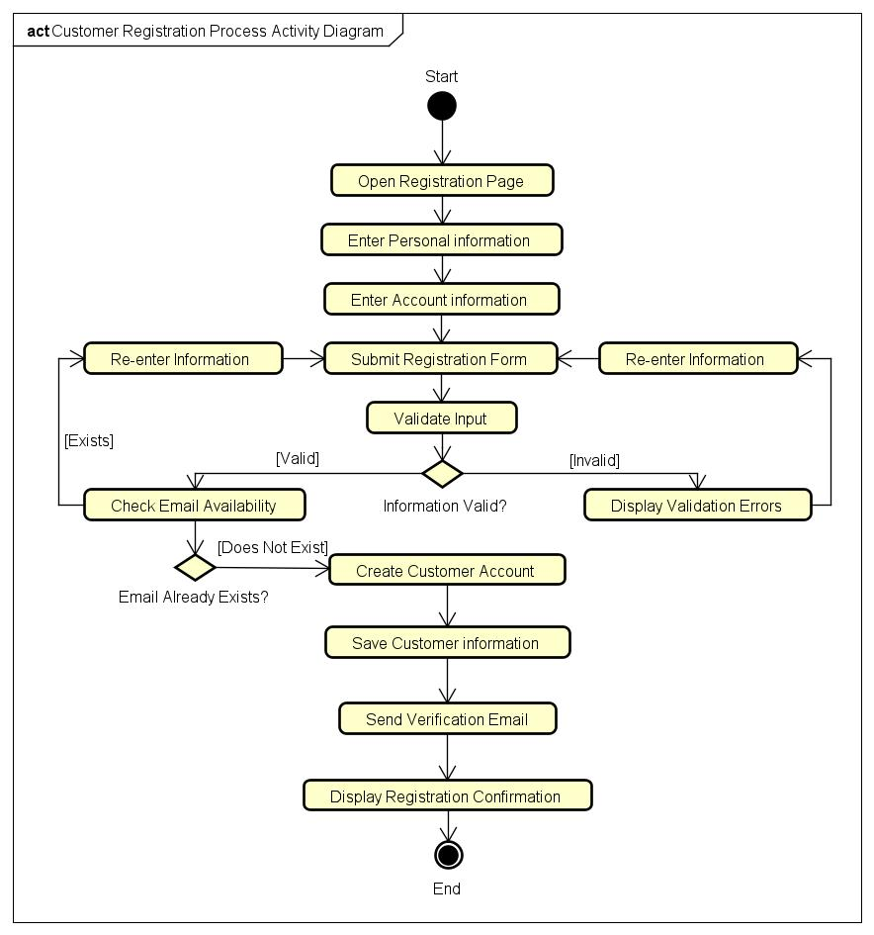
Figure 1 - Customer Registration Process Activity Diagram

2- Vehicle Search & Selection Activity
Purpose
The Vehicle Search & Selection Activity Diagram represents the process by which clients search for available vehicles and choose a fitting vehicle to make a reservation in the KriGo system. The diagram presents the activities, decisions, and alternatives related to finding vehicles that meet client requirements.
Workflow Description
The process starts with the client accessing the vehicle search screen. The client sets the search criteria, such as pick-up point, rental period, car type, price range, and other filters. Then, all vehicles that fit the set criteria and are available for the required period of time will be retrieved.
In case there are no vehicles that meet the set criteria, the customer will be notified about the result and allowed to change the criteria and perform the search again.
If there are some vehicles that meet the set criteria, the client examines the list of search results and chooses a particular vehicle that he/she wants to examine further and see all the details about the chosen one.
Then, the client makes the decision regarding the suitability of the chosen vehicle for renting and proceeds either to making the reservation or continues to search for other fitting vehicles.
Main Activities
The Vehicle Search & Selection Activity Diagram includes the following primary activities:
- Open the vehicle search interface.
- Enter search criteria.
- Submit the search request.
- Retrieve matching available vehicles.
- Display search results.
- Browse available vehicles.
- Select a vehicle.
- View vehicle details.
- Proceed to the reservation process.
Decision Points
The activity diagram contains two primary decision nodes:
- Vehicles Found?
  - If yes, the customer browses the available vehicles.
  - If no, the system displays a message indicating that no vehicles match the search criteria, allowing the customer to modify the search.
- Vehicle Meets Requirements?
  - If yes, the customer proceeds with the reservation process.
  - If no, the customer returns to the search results to evaluate other vehicles.
These decision points ensure that customers can efficiently identify vehicles that best satisfy their rental preferences while handling situations where no suitable vehicles are immediately available.
Alternative Flows
The Vehicle Search & Selection Activity Diagram incorporates several alternative scenarios:
- No vehicles match the specified search criteria.
- The selected vehicle does not satisfy the customer's preferences.
- Successful vehicle selection leading to the reservation process.
These alternative paths provide flexibility during the vehicle selection and enhance overall UX.
Conclusion
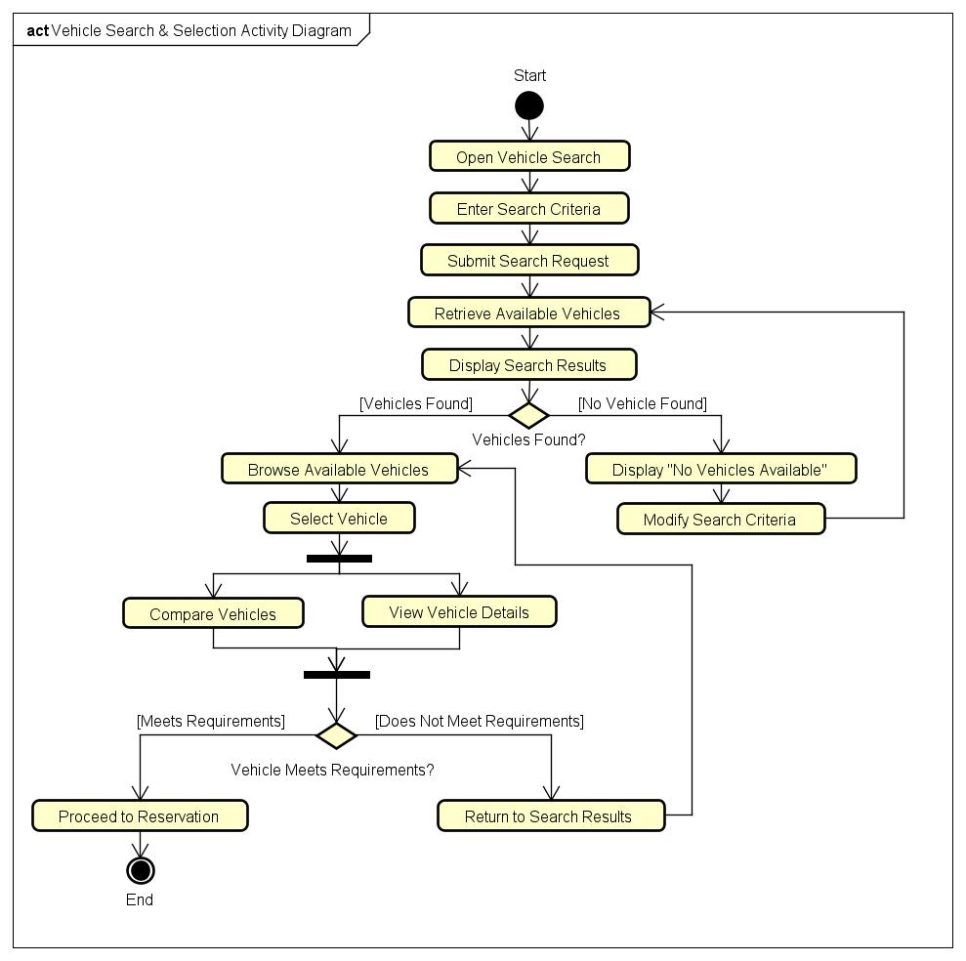
The Vehicle Search and Selection Activity Diagram give a detailed view of all the processes included in the process of finding and selecting rental cars within the KriGo application. The diagram shows how these processes are structured logically, starting with the entry of search parameters and ending with the selection of a suitable vehicle.
Figure 2 - Vehicle Search & Selection Activity Diagram

3- Reservation Workflow Activity
Purpose
Activity Diagram of Reservation Process Workflow is a diagram that shows all activities performed when making a car reservation in the KriGo system. The activity diagram demonstrates the entire reservation process from choosing a car and inserting reservation details to checking its availability, calculating the price of the car, confirming the reservation and saving the reservation information.
Workflow Description
The process of making reservations involves the choice by the customer of a car among the available search results. The next step is providing the required information on the rental: location of picking up, dates of pick up and return, and making a reservation.
When the system gets the request, it checks the availability of the chosen car within the requested period of time. If the vehicle is not available, the customer gets informed about this fact and is redirected to the vehicle search page.
If the chosen vehicle is available, the system calculates the price of the rental based on the rental period and rules.
After reviewing the reservation details, the customer makes a decision on reserving the car. In case of making the reservation, the system saves the reservation information and sends the confirmation message to the customer. If the client does not want to reserve the car anymore, the reservation process is cancelled.
Main Activities
The Reservation Workflow Activity Diagram includes the following primary activities:
- Select a vehicle.
- Enter reservation details.
- Submit the reservation request.
- Check vehicle availability.
- Calculate the rental cost.
- Display the reservation summary.
- Confirm the reservation.
- Create and save the reservation.
- Display the reservation confirmation.
Decision Points
The activity diagram contains two main decision nodes:
- Vehicle Available?
  - If Yes, the reservation process continues with rental cost calculation and reservation review.
  - If No, the customer is informed that the vehicle is unavailable and returns to the vehicle search process.
- Confirm Reservation?
  - If Yes, the reservation is created and stored successfully.
  - If No, the reservation process is canceled without saving any data.
These decision points ensure that reservations are created only for available vehicles and only after explicit customer confirmation.
Alternative Flows
The Reservation Workflow Activity Diagram incorporates several alternative scenarios:
- The selected vehicle is unavailable for the requested rental period.
- The customer cancels the reservation before confirmation.
- Successful reservation creation and confirmation.
These alternative paths improve system reliability by preventing duplicate bookings and allowing customers to review their reservation details before finalizing the transaction.
Conclusion
Reservation Workflow Activity Diagram acts as the most detailed description of the whole process of reserving a car through the KriGo system. It describes the entire logical sequence of actions, validations, and decisions needed to reserve the car. This activity diagram is a vital part of behavioral modeling of the reservation subsystem.
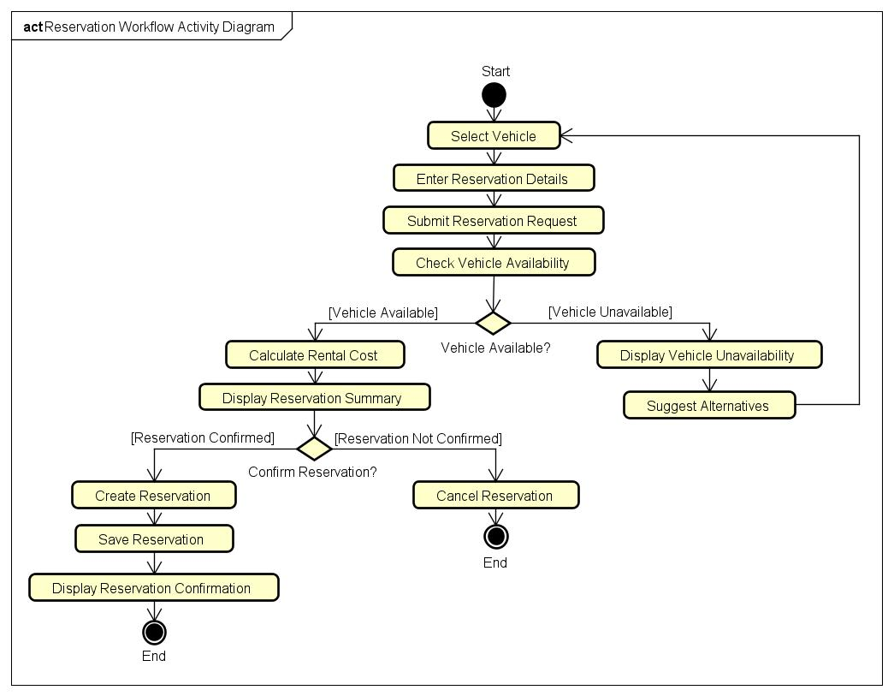
Figure 3 - Reservation Workflow Activity Diagram

